 | Computer Proficiency Language (CS001)  Assignment # 01  Fall 2023 | Total marks = 20  Deadline  15th of November 2023
Please carefully read the following instructions before attempting the assignment.

RULES FOR MARKING
It should be clear that your assignment would not get any credit if:
- The assignment is submitted after the due date.
- Strict action will be taken if the submitted solution is copied from any other student or the internet.

You should consult the recommended books to clarify your concepts as handouts are not sufficient.

UPLOADING INLINE ASSIGNMENT INSTRUCTION
Follow the given instructions to submit Inline assignments:
Microsoft Word (doc/docx) and Adobe Acrobat (pdf) file uploading options will not be available in inline assignment submission.
- Students can submit HTML, Images, and plain text only in this inline Mode. You may also insert an image file/table.
- Students can insert the images or snapshots in the following formats.
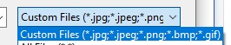
- Images and tables can be inserted using the following highlighted option in the interface.
Topic Covered:
- Module 1 (Introduction to Computers):
  - Introduction to Computers
  - Hardware, Input Devices
  - Software
  - Pointing Devices
  - Storage
  - Security, Output, Internet

NOTE

No assignment will be accepted after the due date via email in any case (whether it is the case of load shedding or internet malfunctioning etc.). Hence refrain from submitting assignments in the last hour of the deadline. It is recommended to submit the solution at least two days before its closing date.

If you people find any mistake or confusion in the assignment (Question statement), please consult with your instructor before the deadline. After the deadline, no queries will be entertained in this regard. Do not post assignment related queries on course MDB.

For any query, feel free to contact at:
cs001@vu.edu.pk
Questions No 01 10 marks
Identify the printer type and write down only the name of the printer against each number pointed in the following image. DO NOT PASTE the pictures in answer, just write the NAME only.

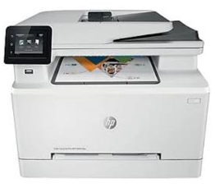1 | 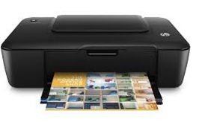  2 | 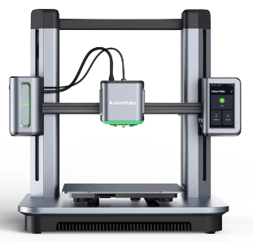  3
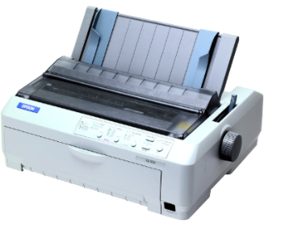  4 | 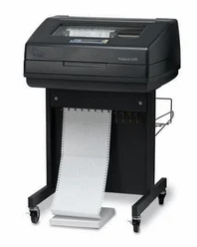5

1. Type the printer name here
2. Type the printer name here
3. Type the printer name here
4. Type the printer name here
5. Type the printer name here

Questions No 02 10 marks
Identify the Storage, Software, Input, and Output devices from the given list.
# | List | Storage | Software | Input | Output
 | Keyboard (Example) | - | - | Yes | -
1 | LCD
2 | RAM
3 | Braille reader
4 | Microsoft Excel
5 | GPS
6 | Joystick
7 | Headphone
8 | Bar code reader
9 | USB
10 | VLC media player

