 | Assignment No. 1  Semester: Fall 2022  CS201 – Introduction to Programming | Total Marks: 20  Due Date: 05th December 2022
Instructions
Please read the following instructions carefully before submitting assignment:
It should be clear that your assignment will not get any credit if:

- Assignment is submitted after due date.
- Submitted assignment does not open or file is corrupt.
- Assignment is copied (From internet/students).

Recommended tool to develop Assignment
- Dev C++

Objectives:
To enable students to understand and practice the concepts of:
- Data Types and Variables
- Arithmetic and Logical Operators
- Expression Solving
- If-else Statements
- Repetition Structure
- Function

Assignment Submission Instructions
You have to submit only .cpp file on the assignments interface of CS201 from your LMS account. Assignment submitted in any other format(like doc, docx, pdf, giff,jpg etc.) will be scaled with zero mark. So, check your solution file format before submission.

For any query related to assignment, please contact cs201@vu.edu.pk.

Lectures: 1 to 10

Assignment
Write a C++ program to prompt the user to enter the Scale and then print the Employee’s Basic Pay, House Rent Allowance and Total Pay by using a function.

Calculations are given as:
Scale | Salary | House Rent(% of salary) | Utility Allowance
1 | 50000 | 10 | 3000
2 | 70000 | 10 | 5000
3 | 90000 | 10 | 7000

Note: The scale should be between 1 and 3 otherwise the system will ask for the correct scale again.

As a result, you should have the following output:

If the user enter 1:

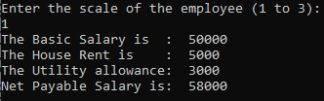

If the user enter 2:

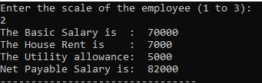

If the user enter 3:

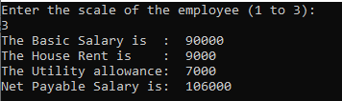

If the user enters input other than 1, 2 and 3. Then program should prompt the user to enter the correct scale of the employee again.

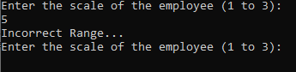

Lectures Covered: 1 to 10
Due date: 05th December,2022

