Problem statement:

You are required to construct AVL tree from the following data:
15,18,12, 8,54,5,14,13,9,61,20,17,21
By inserting (5) and single right rotation following shape will be form:

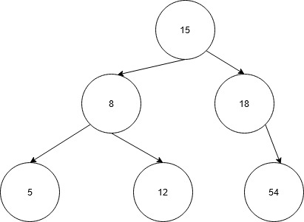
By inserting 13 and rotation following shape will be form:
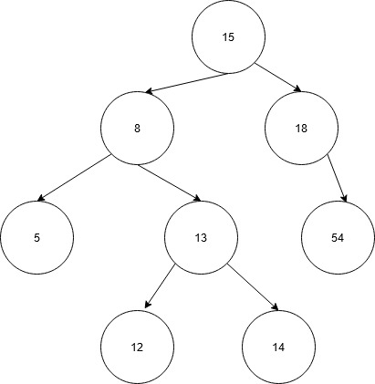
By inserting 9 and rotation following shape will be form:
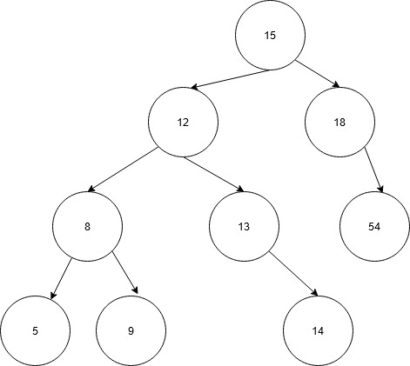
By inserting 61 and rotation following shape will be form:
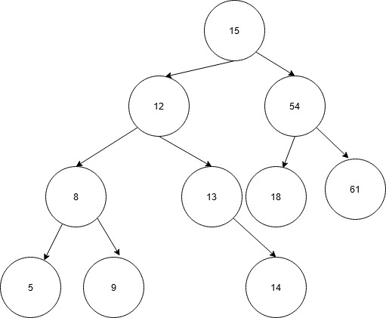

By inserting 21 and rotation following shape will be form:
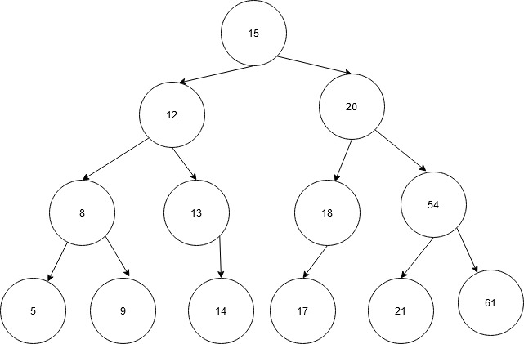

FINAL DIAGRAM

