Assignment: MTH601 (Fall 2020)

Maximum Marks: 15 Due Date: 02-12-2020

DON’T MISS THESE: Important instructions before attempting the solution of this assignment:
• To solve this assignment, you should have good command over 01 - 09 lectures.
- Try to get the concepts, consolidate your concepts and ideas from these questions which you learn in the 01 to 09 lectures.
• Upload assignments properly through LMS, No Assignment will be accepted through email.
• Write your ID on the top of your solution file.
- Don’t use colourful backgrounds in your solution files.
- Use Math Type or Equation Editor etc. for mathematical symbols.
- You should remember that if we found the solution files of some students are same then we will reward zero marks to all those students.
- Try to make a solution by yourself and protect your work from other students, otherwise, you and the student who send the same solution file will be given zero marks.
- Also, remember that you are supposed to submit your assignment in MS Word file format any other like scan images etc. will not be accepted and we will give zero marks corresponding to these assignments.

Question:
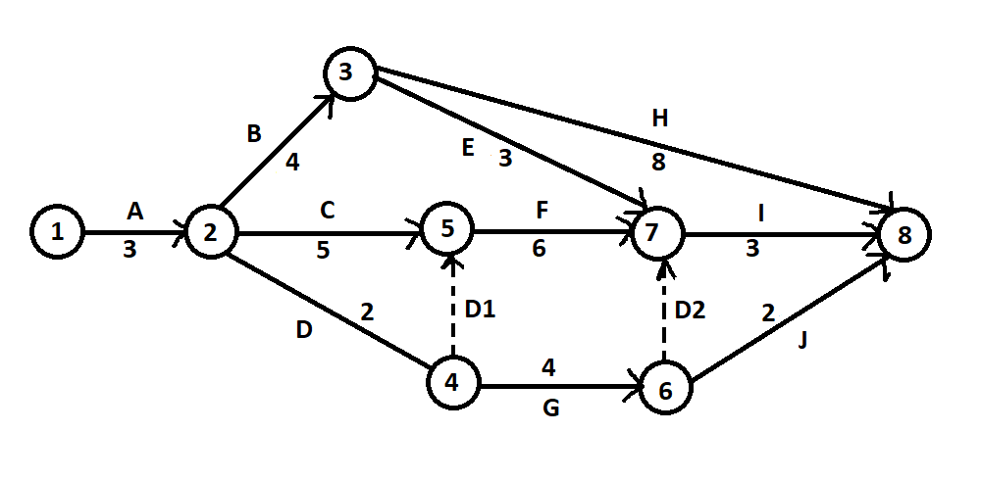
Construct a table which shows the relationship between the activities and their predecessors.

2. Calculate the following time estimates for each activity.

- Earliest Start Time (EST)
- Earliest Finish Time (EFT)
- Latest Start Time (LST)
- Latest Finish Time (LFT)

3. Calculate the total float for each activity.

4. Identify the critical path.

5. Find the project completion time.

Note: The duration of each given activity is in days.

