CS302 Digital Logic Design Assignment 1 Solution & Discussion Spring 2020

Join us Cyberian.pk
Total marks = 20 Dead line: 01-06-2020

Question no.1: Perform decimal to binary conversion on given decimal number using Sum-of- Verify the answer using repeated division method.
weights method.
Decimal Number=1050
Solution:
Sum of weight method Decimal to Binary

Sum of Term | Highest Weight | Binary Number | Sum of Term – Highest Weight
1050 | 1024 | 10000000000 | 26
26 | 16 | 10000100000 | 10
10 | 8 | 10000011000 | 2
2 | 2 | 10000011010 | 0

By Sum of Weight Method (1050)₁₀ = (10000011010)₂

Now Verification by repeated division method is

Question no.2: Perform the following arithmetic operations. For conversion you can use indirect method of conversion only.
(E2BC3F)₁₆ − (10110101000000011110001)₂ + (537476217)₈ = ( ___)₁₆

Solution:
(E2BC3F)₁₆ − (10110101000000011110001)₂ + (537476217)₈ = ( )₁₆
i. (E-2-B-C-3-F)₁₆
ii. (101-1010- 1000- 0000-1111- 0001)₂ = (5-A-8-0-F-1)₁₆
iii. (537476217)₈ ₌ (101-011-111-100-111-110-010-001-111)₂
Converting 3 bit to 4 bit
(0101-0111-1110-0111-1100-1000-1111)₂
Converting 4 bit to Hexadecimal (5-7-E-7-C-8-F)₁₆
So now Our Equation is in one Number System (E2BC3F)₁₆ –(5A80F1)₁₆+(57E7C8F)₁₆ =(606B7DD)₁₆
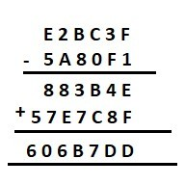

Question no.3: Perform BCD addition between these two numbers. Kindly perform all the steps.
- 46
- 37
Solution:
BCD is a representation of single digit in 4 bits and for decimal its 0 to 9 only So adding two Numbers by converting them in BCD we have:
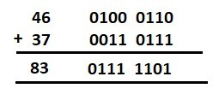
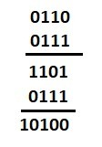
As carry is generated so

1 is carry in 10100,
So now add this 1 carry on 0111
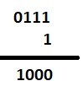

So adding One carry in Binary Our Answer will be (1000 0100)_{bcd}

Join us Cyberian.pk

