Assignment No. 01 Solution
Semester Fall 2019
CS508- Modern Programming Languages

Language | Code | CPU Time | Memory Used
C++ | #include <iostream>  using namespace std;  int main() {  cout<< "My id is BC180401429 \n";  cout<< "** Language is C++ ** \n";  for(int i=0;i<=14;i++){  for(int j=0;j<=29;j++){  cout<< "Outer:"<<i<<"Inner:"<<j;  }  }  } | 0.00 | 3304 KB
JAVA | public class MyClass {  public static void main(String args[]) {  System.out.println("My id is BC180401429");  System.out.println("** Language is JAVA **");  for(int i=0;i<=14;i++){  for(int j=0;j<=29;j++){  System.out.print("Outer:"+i+"Inner:"+j);  }  }  }  } | 0.32 | 36020KB
C# | using System;  class Program  {  static void Main() {  Console.WriteLine("My id is BC180401429");  Console.WriteLine("** Language is C# **");  for(int i=0;i<=14;i++){  for(int j=0;j<=29;j++){  Console.Write("Outer:"+i+"Inner:"+j);  }  }  }  } | 0.03 | 25356KB

Screen Shots of compilation
C++
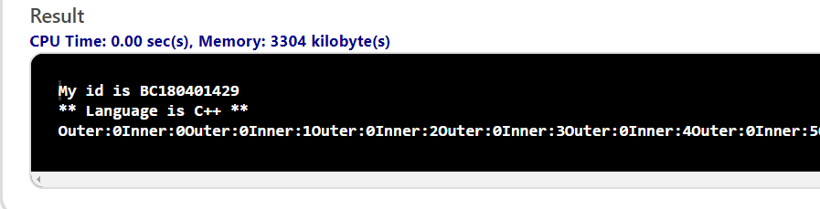
JAVA
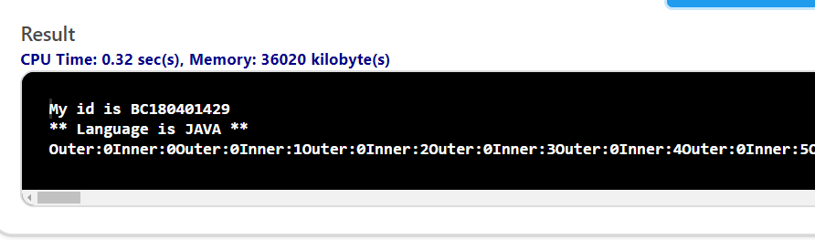
C#