CS403 ASSIGNMENT NO 2 SOLUTION FALL 2019:
QUESTION NO 1:
CONVERT ERD INTO RELATION DATA MODEL

Solution:
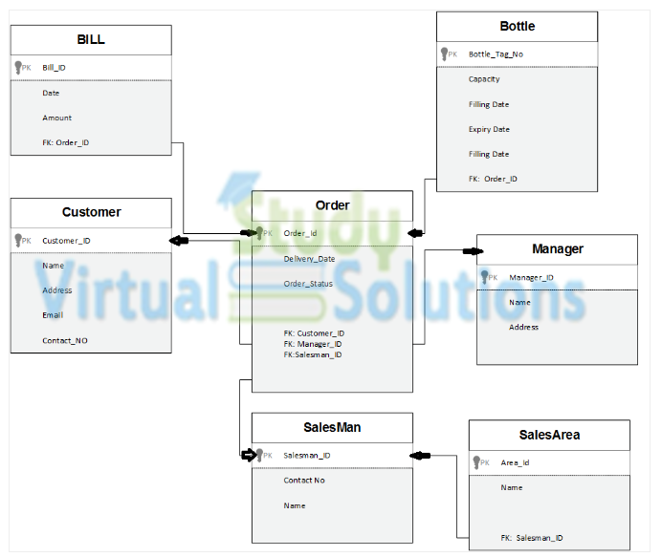

Question No 2:
Order:
order_id | order_status | delivery_date | btag_no | cust_id | sman_id
od001 | Completed | 10/30/2019 | bt001 | cust001 | sm001
od002 | Completed | 10/30/2019 | bt002 | cust002 | sm001
od003 | Completed | 10/30/2019 | bt003 | cust003 | sm001
Bill:
bill_id | cust_id | order_id | net_amount
b001 | cust001 | od001 | 500
b002 | cust002 | od002 | 550
b003 | cust001 | od003 | 600

And write the output of the following relational algebra operations:
- ∏ order_id, cust_id, sman_id (Order)

∏ Operator name is projection this is used to select all the colum in the table
It will select three colums, order_id, sman_id and cust_id. It also delete the unwanted colums on the basis of condition
- σ net_amount > 500 (Bill)
σ is used for selection. it select the subset of rows from table answer will be second and third row from bill table answer will be (550,600)
- ∏ order_status, delivery_date (σ btag_no= ‘bt002’ (Order))
In this it will first perform the selection and select the btag no row from order table then projection will be performed and in projection it will selct the colum order-status value and delivery date value where btag no is bt002.
Answer will be order status delivery date
Completed 10/30/2019

Question no 3:
- Find the degree and cardinality of the relations (Order and Bill) given in the 2nd question.
(a)
Degree = number of attributes or colums in the table is his degree
Order table have 6 colums/attributes so its degree will be 6
Bill table have 4 colums/attributes so its degree will be 4
Degree of the (Order and Bill) will be
Degree -> 6+4=10
(b)
Cardinality = numbers of tuples/rows in the table
Number of rows in order table = 3
Number of rows in bill table =3
Cardinality of order and bill (rows*rows)
Cardinality -> 3*3 =9

