SUBJECT CODE: MTH601
Assignment # 01 Spring 2019

Note: Please Check it twice by yourself and also make some changes, Don’t make exact copy paste technique otherwise you will get mark 0 (zero) if you make same copy.
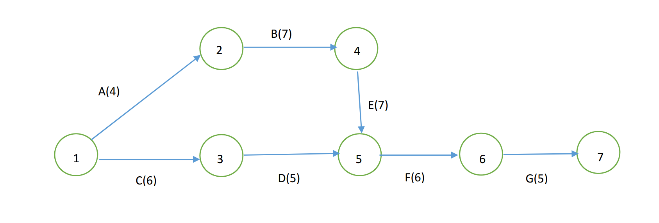
Solution:
- Construct the table which shows the relationship
Activities | Predecessor
A | -
B | A
C | -
D | C
E | B
F | D, E
G | F

- Calculate the following
  - Earliest Start Time
  - Earliest Finish Time
  - Latest Start Time
  - Latest Finish Time
Answer:
Activity | Earliest Start Time | Earliest Finish Time | Latest Start Time | Latest Finish Time
A | 0 | 4 | 0 | 4
B | 4 | 11 | 4 | 11
C | 0 | 6 | 6 | 12
D | 6 | 11 | 13 | 18
E | 11 | 18 | 11 | 18
F | 18 | 24 | 18 | 24
G | 24 | 29 | 24 | 29

- Calculate the total float of each activity
Answer: Float = Latest Finish Time – Earliest Finish Time
Activity | Float
A | 0
B | 0
C | 6
D | 7
E | 0
F | 0
G | 0

- Critical Path
There are 2 Paths
A+B+E+F+G = 4 +7 + 7 +6+5 = 29
C+D+F+G=6+5+6+5 =22
A+B+E+F+G longest Path hence it is critical path 29

- Project Completion Time is 29 Days

