 | Assignment No. 1  Semester: Spring 2019  CS614 – Data Warehousing |  | Total Marks: 20  Due Date:  May 15, 2019
Objectives:
After completing this assignment the students will be able to:
- Identify Database entities from a given scenario
- Understand the database table structure
- Normalize a database table up to 3rd normal form

Instructions
Please read the following instructions carefully before submitting assignment:
It should be clear that your assignment will not get any credit if:

- Assignment is submitted after due date.
- Submitted assignment does not open or file is corrupt.
- Assignment is copied (From internet/ to from students).
- Assignment is submitted other than word format (.doc, .docx).

Assignment
XYZ company was established in 1989 in Karachi and deals in the business of garments export. There are 250 permanent employees that are working with XYZ company. XYZ’s admin department is maintaining employee’s leave records in hard form. The leave form currently in practice is shown below:

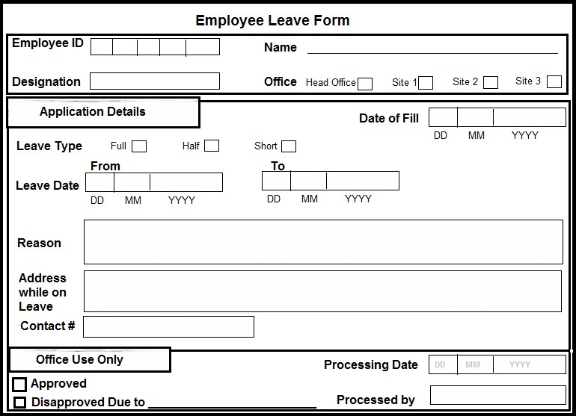

Now XYZ company wants you to design a Database solution for their organization, you are required to develop a database that is normalized up to the 3rd Normal form. In the future, this database can be used for developing front end application.

A raw table structure along with attributes are provided by the XYZ’s management to start your working on it, is as following;

employeeLeaveForm (employeeID, empName, designation, officeName, dateOfFill, leaveType, leaveFromDate, leaveToDate, leaveReason, leaveAddress, leaveContactNo, leaveProcessDate, leaveStatus, leaveProcessedBy),

Sample data for the table is provided on VULMS for your reference. To view / download this data, use the following link;

https://vulms.vu.edu.pk/Courses/CS614/Downloads/CS614%20-%20SP%202019%20-%20Assignment%201%20-%20Sample%20Data.xlsx

You have to use exact given attributes names while normalizing this table to 3rd Normal form.

Instructions to solve assignment:

- Use table employeeLeaveForm and attributes in it. You are not allowed to remove any of the provided attributes
- You may introduce new tables by using the same attributes in employeeLeaveForm and also add new attributes for indexing / normalization purpose
- You are also required to declare Primary and Foreign Keys from the provided list of attributes (Also represent them with suitable DB notation while writing table schema)
- Transform the table in 3rd normal form step by step i.e. First Normal form transformation then into 2nd normal form and then into 3rd. Also, mention the title of Normal Form before the transformation.
- Direct transform relation into 3rd normal form would result in zero marks whether your solution is correct. And this will be imposed strictly while marking this assignment with no later excuses.
- Example of resultant tables / solution should be in the form provided below:
tableNo1 (attribute1, attribute2, …)
tableNo2 (attributeX, attributeY, …)
tableNo3 (attributeI, attributeX, …)

attribute1, attributeX and attributeI (with solid underline) are primary keys in tableNo1, tableNo2 and tableNo3 respectively while attribute (With dotted underline) is foreign key in tableNo3 from referee tableNo2.

Deadline:
Your assignment must be uploaded on VULMS on or before May 15, 2019. While May 16, 2019 will be a bonus day for assignment submission. After the bonus day, no assignment would be entertained via email.

