 | Operating Systems (CS604)  Assignment # 01  Spring 2019 | Total marks = 20  Deadline Date  14th May 2019
Please carefully read the following instructions before attempting assignment.

RULES FOR MARKING
It should be clear that your assignment would not get any credit if:
- The assignment is submitted after the due date.
- The submitted assignment does not open or file is corrupt.
- Strict action will be taken if submitted solution is copied from any other student or from the internet.

You should consult the recommended books to clarify your concepts as handouts are not sufficient.

You are supposed to submit your assignment in .doc or docx format.
Any other formats like scan images, PDF, zip, rar, ppt and bmp etc will not be accepted.

Objective:
- The objective of this assignment is to provide hands on experience of:
- To learn and understand the basic concept of an Operating System
- To learn Directory Structure of Operating System

NOTE

No assignment will be accepted after the due date via email in any case (whether it is the case of load shedding or internet malfunctioning etc.). Hence refrain from uploading assignment in the last hour of deadline. It is recommended to upload solution file at least two days before its closing date.

If you find any mistake or confusion in assignment (Question statement), please consult with your instructor before the deadline. After the deadline no queries will be entertained in this regard.

For any query, feel free to email at:
cs604@vu.edu.pk

Question No 01 10 marks

The following figure shows the directory structure in a UNIX/Linux system. Suppose, user Hassan has a subdirectory named courses under his home directory. This directory contains subdirectories for the courses that he has taken i.e. (CS401 and CS604).
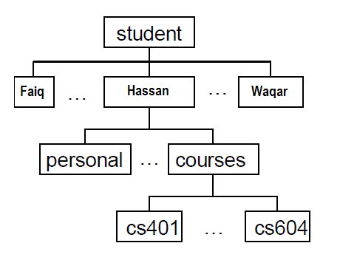

If hassan is currently in the courses directory than write the UNIX/Linux commands to perform following operations.

- How he can navigate back to his home directory?
- How he can navigate to his personal directory?
- How he can navigate to the directory for cs604 course?
- Right after the login, how he can display names of files and directories in his home directory?
- How he can create a new directory named programs under cs604 directory?

Question No 02 10 marks

The following table contains the list of operations based on important directories in the Linux operating system; you are required to mention the directory names used in Linux operating system against each desired output operation.

Sr # | List of Operations | Directory
1 | To contain the devices available to Linux
2 | Used for mounting temporary file systems
3 | To store system configuration files
4 | For the storage of large applications packages
5 | To store shared libraries and kernel modules

Wish you very Best of Luck!

